Digital Logic Lab 9 Report

Digital Logic 2116L

4/10/2018

Featheringill 210

Suyi Diao, Bryce

1. Introduction:

The basic concepts we learned for this lab is how to build counters and registers and how to put them together in a more efficient way using buses.

1. Design Requirements:

We need to build the circuit from prelab of the lab into the mother board, a circuit that accepts two inputs: a push button and a dip switch, which switches between counters and shift registers

1. Diagrams

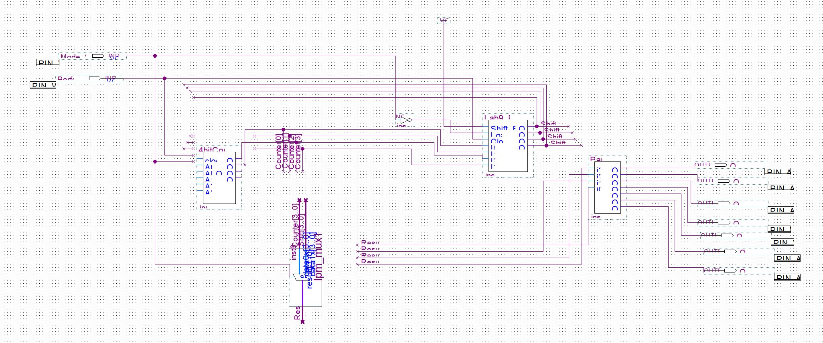

1. Results

The lab runs smoothly and correctly on the motherboard.

1. Discussion

Everything in the lab runs smoothly, we did the prelab and the implementation process to the board took a lot of time

1. Conclusion

I learned how to use buses to build the circuit more efficiently.

1. Post-Lab Questions

Suppose I need an 8-bit counter and an 8-bit shift register, I would create the circuit using what I have already created. First, I would create 8-bit counter using two 4 bits counter and 8-bit shift register the same way. Then I would connect those in the diagram provided and change the mux to be 8 bits wide input.